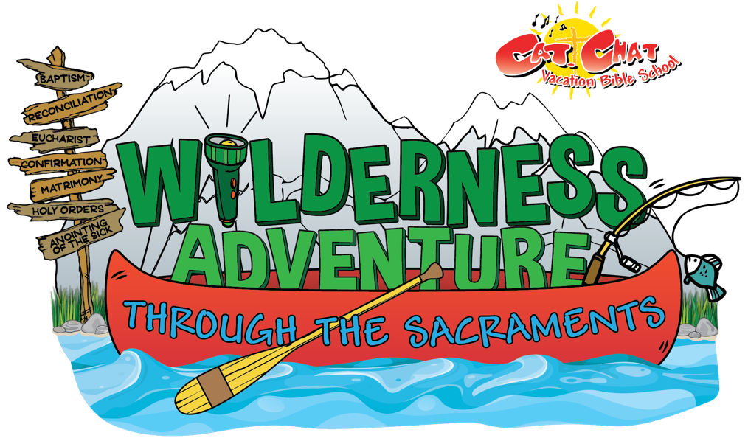

St. Damian and St Bernard’s are planning a
Vacation Bible School program
this summer for kids ages 4 -10.

Join the VBS Team!

If you are interested in helping our kids learn their Catholic faith in a fun and exciting way, please return the completed form to any Faith Formation teacher or the basket in church by May 4, 2024

The theme is A Wilderness Adventure Through the Sacraments, the dates are June 10 -June 14th from 9:00 AM until Noon.

----------------------------------------------------------------------------------------------------------------------------------

❑ Yes! I want to help kids learn more about the Sacraments!

I am interested in helping with: (please check as many as interest you)

 Faith Lessons  Music  Crafts  Snacks
 Games  Group Leader  Decorating  Welcome Committee
 Registration/Sign-In  Skits  Photo/Video  Computer Support

 Other: ________________________

Name: ________________________________________________________________________

Address: ______________________________________________________________________

Phone Number: _________________________________________________________________
(day) (evening)

Parent Signature if a student : ________________________________________________________________________

